Proof of testing for number 3

Array values: [1 2; 3 4; 5 6; 7 8; 9 0]

Code and Coefficients value

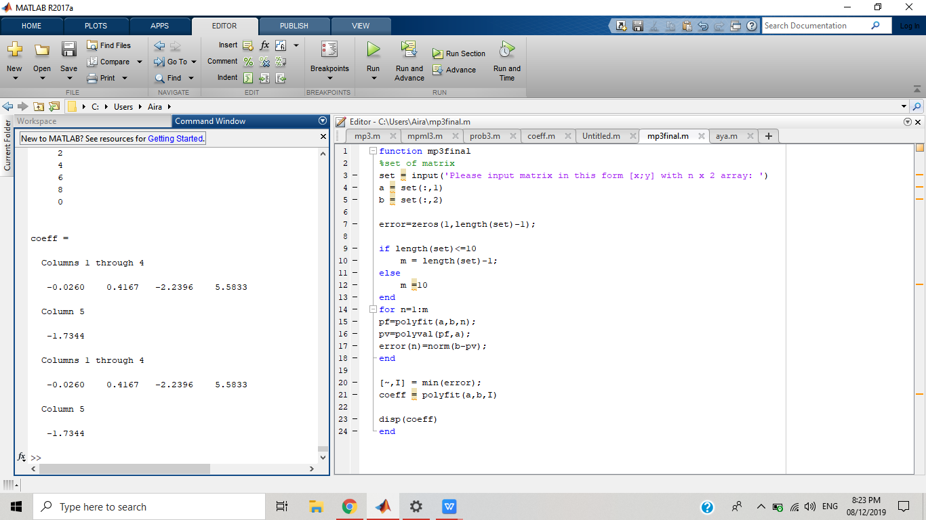

Array values: [2,1;5,4;2,6;7,8;6,4;9,8;6,7;9,3;6,1]

Code and Coefficients value

